TABLE OF CONTENTS

List of Figures iii

List of Screenshot iv

Abstract v

1 INTRODUCTION 1

1.1 Overview 1

1.2 Problem Statement 4

1.3 Project Objectives 5

1.4 Need Of Application 9

2 LITERATURE SURVEY 11

2.1 Review 11

2.2 Related Work 12

3 SYSTEM ANALYSIS 17

3.1 Problem Statement 17

3.2 System Requirements 17

3.3 Technologies Involved 18

3.3.1 Pycharm 18

3.3.2 OpenCV 19

4 SYSTEM ARCHITECTURE 20

4.1 Architecture 20

4.2 OpenCV 20

4.3 Use Case Diagram 22

4.4 Data Flow Diagram (DFD) 23

4.5 Flow Chart Diagram 24

5 IMPLEMENTATION AND RESULTS 26

5.1 Implementation 26

5.1.1 Modules 26

5.1.2 Decision Tree-Regression 27

5.1.3 Gradient Boosting 27

5.1.4 Library Used 28

5.1.5 Clicking Activity 28

5.1.6 Algorithm 28

5.2 Results 29

5.2.1 Detection of Eyes 30

5.2.2 Detection of Eye Balls 30

5.2.3 Working of Mouse 31

5.2.4 Clicking Activity 31

5.2.5 Final Result 32

6 APPLICATIONS, ADVANTAGES AND DISADVANTAGES 33

6.1 Applications 33

6.2 Advantages 34

6.3 Dis-Advantages 35

7 CONCLUSION AND FUTURE SCOPE 37

7.1 Conclusion 37

7.2 Future Scope 38

REFERENCES 39

List of Figures

Figure 1.1 : Eye detection and Cursor movement 4

Figure 1.2 : Mapping result of Eye 8

Figure 2.1 : Mapping rate determination 12

Figure 3.1 : Overview of system 17

Figure 4.1 : Architecture Diagram 20

Figure 4.2 : The 6 facial points linked with the eye 20

Figure 4.3 : Use Case Diagram 23

Figure 4.4 : Data Flow Diagram 24

Figure 4.5 : Application Flowchart 25

Figure 5.1 : Detection of point of gaze 26

Figure 5.2 : Regression tre Architecture 27

Figure 5.3 : Blink Actions 28

Figure 5.4 : Identifying facial Landmarks 29

LIST OF SCREENSHOTS

Screenshot 5.1: Detection of Eyes Through Webcam 30

Screenshot 5.2: Detection of Eye balls to get Aspect Ratio 30

Screenshot 5.3: Working of Mouse by Movement of Eyes 31

Screenshot 5.4: Cursor Movement And Clicking Activity through Eyes 31

Screenshot 5.5: Cursor get Clicked on selected button by blinking of Eyes 32

## ABSTRACT

There are different reasons for which people need an artificial of locomotion such as a virtual keyboard. The number of people, who need to move around with the help of some article means, because of an illness. Moreover, implementing a controlling system in it enables them to move without the help of another person is very helpful. The idea of eye controls of great use to not only the future of natural input but more importantly the handicapped and disabled. Camera is capturing the image of eye movement. First detect pupil center position of eye. Then the different variation on pupil position get different command set for virtual keyboard. The signals pass the motor driver to interface with the virtual keyboard itself. The motor driver will control both speed and direction to enable the virtual keyboard to move forward, left, right and stop.

An individual Human computer interference system is being introduced. In olden times, as an input device the mouse and keyboard were used by human computer interference system. Those people who are suffering from certain disease or illness cannot be able to operate computers. The idea of controlling the computers with the eyes will serve a great use for handicapped and disabled person. Also this type of control will eliminate the help required by other person to handle the computer. This measure will be the most useful for the person who is without hands through which they can operate with the help of their eye movements. The movement of the cursor is directly associated with the center of the pupil. Hence our first step would be detecting the center of point pupil. This process of pupil detection is implemented using the OpenCV.

# INTRODUCTION

### Overview

Nowadays personal computer systems are carrying a huge part in our everyday lives as they are used in areas such as work, education and enjoyment. What all these applications have in common is that the use of personal computers is mostly based on the input method via keyboard and mouse. While this is not a problem for a healthy individual, this may be an insurmountable bound for people with limited freedom of movement of their limbs. In these cases it would be preferable to use input methods which are based on more abilities of the region such as eye movements. To enable such substitute input methods a system was made which follows a low-price approach to control a mouse cursor on a computer system. The eye tracker is based on images recorded by a mutated webcam to acquire the eye movements. These eye movements are then graphed to a computer screen to position a mouse cursor accordingly. The movement of mouse by automatically adjusting the position of eyesight. Camera is used to capture the image of eye movement. In general, any digital image processing algorithm consists of three stages: input, processor and output. In the input stage image is captured by a camera. It sent to a particular system to focus on a pixel of image that’s gives, its output as a processed image.

As the computer technologies are growing rapidly, the importance of human computer interaction becomes highly notable. Some persons who are disabled cannot be able to use the computers. Eye ball movement control mainly used for disabled people. Incorporating this eye controlling system with the computers will make them to work without the help of other individual. Human-Computer Interface (HCI) is focused on use of computer technology to provide interface between the computer and the human. There is a need for finding the suitable technology that makes the effective communication between human and computer. Human computer interaction plays the important role .Thus there is a need to find a method that spreads an alternate way for making communication between the human and computer to the individuals those who have impairments and give them an equivalent space to be an element of Information Society [1-5]. In recent years, the human computer interfaces are attracting the attention of various researchers across the globe. Human computer interface is an implementation of the vision-based system for eye movement detection for the disabled people.

Embedded system is combination of hardware and software. An embedded system can be an independent system or it can be a part of a large system. An embedded system is a microcontroller or microprocessor based system which is designed to perform a specific task. For example, a fire alarm is an embedded system; it will sense only smoke Python is a high-level language. This means that Python code is written in largely recognizable English, providing the Pi with commands in a manner that is quick to learn and easy to follow. This is in marked contrast to low-level languages, like assembler, which are closer to how the computer ―thinks but almost impossible for a human to follow without experience. As the computer technologies are growing rapidly, the importance of human computer interaction becomes highly notable. Some persons who are disabled cannot be able to use the computers. Eye ball movement control mainly used for disabled people .

Disable people that cannot move anything except their eyes. For these people eye movement and blinks are the sole thanks to communicating with the outside world through the computer. This analysis aims in developing a system which will aid the physically challenged by permitting them to act with a computing system mistreatment solely their eyes. Human-Computer interaction has become an associated progressively vital part of our daily lives. There is no universal method to trace the attention movement. The project principally includes 3 sections particularly Image Capture, Image process, and Cursor Control. The eye gesture system directly interacts with the vision of the human eyes then controls the system. Eye gesture, a real time gesture assurance programming which controls a mouse cursor by using the user’s eye gestures. Our technique principally focuses on the employment of an online camera to develop a virtual human laptop interaction device in a very cost-effective manner presents hands free interface between computer and human especially for physically disabled persons. For using this system, users must have to go through the authentication process in which users' faces will be matched with the authenticated users. If the user is authenticated then only, he/she can log in to the system.

Controlling the mouse by a physically challenged person is really a tough one. To find a solution for the people who cannot use the Mouse physically, we have proposed this mouse cursor control using Eye Movements. Eye gaze is an alternative way of accessing a computer using eye movements to control the mouse. For someone who fine touchscreens, mouse inaccessible, eye gaze is an alternative method to allow a user to operate their computer, using the movement of their eyes. Eye movement can be regarded as a pivotal real-time input medium for human-computer communication, which is especially important for people with physical disability. In order to improve the reliability, mobility, and usability of eye tracking technique in user-computer dialogue, a novel eye control system is proposed in this system using Webcam and without using any extra hardware. The proposed system focuses on providing a simple and convenient interactive mode by only using user’s eye. The usage flow of the proposed system is designed to perfectly follow human natural habits. The proposed system describes the implementation of both iris and movement of cursor according to iris position which can be used to control the cursor on the screen using webcam and implemented using Python.

Thus there is a need to find a method that spreads an alternate way for making communication between the human and computer to the individuals those who have impairments and give them an equivalent space to be an element of Information Society. In recent years, the human computer interfaces are attracting the attention of various researchers across the globe. Human computer interface is an implementation of the vision-based system for eye movement detection for the disabled people. In the proposed system, we have included the face detection, face tracking, eye detection and interpretation of a sequence of eye blinks in real time for controlling a non-intrusive human computer interface. Conventional method of interaction with the computer with the mouse is replaced with the human eye movements. This technique will help the paralyzed person, physically challenged people especially person without hands to compute efficiently and with the ease of use. Firstly, camera captures the image and focuses on the eye in the image using OpenCV code for pupil detection. This results the center position of the human eye (pupil). Then the center position of the pupil is taken as a reference and based on that the human or theuser will control the cursor by moving left and right .

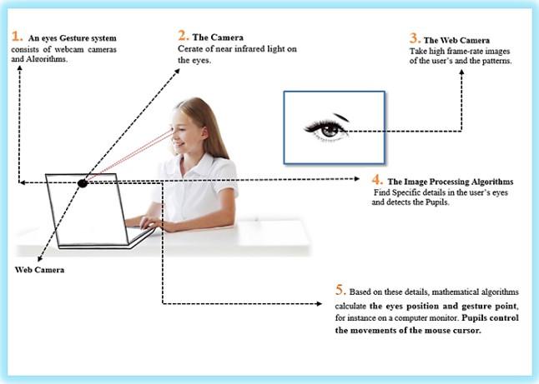

**Fig 1.1 Structure of system Eye detection and Cursor movement**

### Problem statement

Currently as today, there are around 21 million people in India who are suffering from one or more than one physical disabilities which constitutes around 2 percent of India’s population. In today’s era computers have become a significant part of our lives. Such people cannot readily use the computer system. Our problem is to develop a system which can help such people who are physically disabled but visually intact to use the computer system, so that their physical disability won’t hinder their abilities to use a computer.

Many people with physical disabilities, such as spinal cord injuries or muscular dystrophy, face difficulties using traditional computer interfaces such as a mouse or keyboard. One possible solution is to use an eye-tracking system to control the computer cursor. However, even eye-tracking systems can be challenging for some users due to factors such as eye fatigue, sensitivity, or involuntary eye movements.

To address this issue, the concept of "Eye-Guided Mouse Control" has emerged, where the user can move the cursor by simply moving their eyes in a particular direction. However, there are several technical challenges that need to be addressed to make this concept feasible for widespread use.

The primary problem is that eye movements can be subtle and vary greatly from person to person. Therefore, the system needs to be highly accurate and customizable to each individual user. Additionally, the system needs to be able to differentiate between intentional eye movements and involuntary eye movements, such as blinking or twitching.

Moreover, the system needs to be designed to minimize eye fatigue and discomfort, as prolonged use of eye-tracking technology can cause eye strain and headaches. Therefore, the system should have built-in features such as adjustable sensitivity, eye-tracking calibration, and the ability to switch between eye and head movement controls.

Overall, the goal of this project is to develop a robust, user-friendly, and accessible eye-tracking system that can be used by people with physical disabilities to improve their computer interaction experience.

### Project objectives

The main objective of the "Eye-Guided Mouse Control" project is to develop a reliable and intuitive system for cursor control that uses eye-tracking technology to accurately capture and interpret the movement of the user's eyes. The system will be designed to enhance the accessibility and usability of computer interfaces for individuals with disabilities, as well as for the general population. The project aims to explore the potential applications of this technology in various fields such as gaming, virtual reality, and healthcare.

One of the primary goals of the project is to explore the potential applications of this technology in various fields such as gaming, virtual reality, and healthcare. For example, in the gaming industry, eye-tracking technology can be used to create more immersive and interactive gaming experiences. In healthcare, eye-tracking technology can be used to assist in the diagnosis and treatment of eye-related diseases, as well as to improve the efficiency and accuracy of surgical procedures.

1. **To develop a reliable and accurate system for cursor control that uses eye-tracking technology:** The goal of this objective is to create a system that can accurately track and interpret the movement of a user's eyes in real-time to control the movement of a cursor on a computer screen. This will require the use of advanced algorithms and machine learning techniques to accurately interpret eye.
2. **To enhance the accessibility and usability of computer interfaces for individuals with disabilities:** The aim of this objective is to make computer interfaces more accessible and user-friendly for individuals with disabilities, such as those with motor impairments or conditions like ALS. By using eye-tracking technology, individuals with disabilities will be able to control the cursor on a computer screen without requiring any physical movement, making it easier for them to interact with computers and technology.
3. **To explore the potential applications of eye-tracking technology in various fields:** This objective aims to investigate the potential uses of eye-tracking technology beyond just cursor control. This could include applications in fields such as gaming, virtual reality, healthcare, and more. By exploring these potential applications, we can better understand the broader impact that eye-tracking technology could have on society.
4. **To design an intuitive and user-friendly system for eye-based cursor control:** This objective focuses on creating a system that is easy for users to understand and use. This will require the development of a user interface that is clear and concise, and that provides users with clear feedback on the movement of the cursor. By designing a system that is intuitive and user-friendly, we can ensure that individuals with disabilities and other users can easily adapt to and make use of the technology.
5. **To conduct user testing and gather feedback from individuals with disabilities:** This objective involves working closely with individuals with disabilities to test the system and gather feedback on its usability and effectiveness. This feedback will be used to refine the system and to ensure that it meets the needs of its intended users. By conducting user testing and gathering feedback, we can ensure that the system is effective and useful for individuals with disabilities.
6. **To contribute to the field of human-computer interaction with innovative technology:** This objective aims to contribute to the field of human-computer interaction by developing new and innovative technology that can improve the way we interact with computers and technology. By pushing the boundaries of what is currently possible, we can pave the way for new and exciting developments in the field.
7. **To optimize the performance of the eye-tracking system for real-world applications:** This objective aims to optimize the system's performance for real-world use cases, which may involve dealing with different lighting conditions, various screen sizes, and distances between the user and the screen. This objective will involve optimizing the algorithms used to track eye movements, as well as the hardware components used to capture and process eye movement data.
8. **To develop a system that is robust to noise and other sources of interference:** This objective focuses on developing a system that can operate accurately and reliably in environments with high levels of noise or other sources of interference. This will require the development of algorithms that can filter out unwanted signals and noise, as well as the use of high-quality hardware components that are less susceptible to interference.
9. **To investigate the impact of the system on user performance and productivity:** This objective aims to investigate the impact that the eye-tracking system has on user performance and productivity. This will involve conducting experiments to measure the speed and accuracy of cursor control using the eye-tracking system compared to traditional mouse-based input. This data will help us to understand the potential benefits of the eye-tracking system in terms of increased productivity and efficiency.
10. **To design and implement a calibration process that is fast and accurate:** This objective focuses on designing a calibration process that is both fast and accurate, as the accuracy of the eye-tracking system depends on how well the system is calibrated to the user's eyes. This will require the development of a calibration process that is easy to follow and takes minimal time, while still providing accurate results.
11. **To investigate the security implications of eye-based cursor control:** This objective aims to investigate the potential security implications of using eye-tracking technology for cursor control. This could include exploring the possibility of using eye-tracking data as a form of biometric authentication, or investigating the potential vulnerabilities in the system that could be exploited by malicious actors. By understanding the security implications of the system, we can ensure that it is designed and implemented in a way that is secure and safe to use.
12. **To explore the potential for using the system as a tool for research in human behavior and cognition:** This objective focuses on exploring the potential for using the eye-tracking system as a research tool for studying human behavior and cognition. This could include investigating how users interact with different types of interfaces or studying the relationship between eye movements and cognitive processes such as attention and memory. By exploring the potential for using the system as a research tool, we can expand our understanding of human behavior and cognition, and potentially develop new applications for the technology.

The system inputs the video frames from the user. The video is pre-processed for enhancement. In this process the noise and the blurriness of the video is handled. The face detection is carried out using the Viola-Jones algorithm. The procedure for further mouse pointer control will be done as follows:-

* Video stream will be captured through the webcam.
* The video input will be broken into frames.
* The frames captured will be in RGB mode. These frames will be converted to grayscale as the further processing will be easier using the grayscale conversion.
* The frames focusing the eyes are used for the detection of the corners of eye.
* 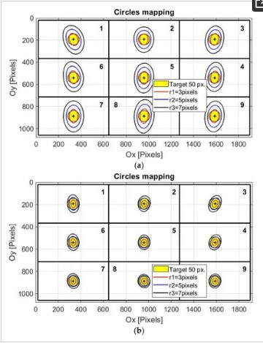The eye point is calculated and the mouse will move from one position to another based on the movements of this eye point.

**Fig 1.2 Mapping result of eye**

### Need of application

The need for a Campus Recruitment Coding Training Platform arises from the significant gap between the skills that students learn in their academic curriculum and the skills that are required by the industry. The current education system often fails to provide students with practical exposure to coding, resulting in a lack of confidence and competence among students when it comes to real-world coding challenges.

The need for an "Eye-Guided Mouse Control" application arises from the fact that many individuals with physical disabilities, such as spinal cord injuries, muscular dystrophy, or cerebral palsy, face significant challenges using traditional computer interfaces such as a mouse or keyboard. These individuals often have limited or no control over their limbs, making it difficult or impossible for them to operate a computer using standard input devices.

Eye-Guided Mouse Control provides an alternative means of computer interaction that is accessible and user-friendly for individuals with physical disabilities. It enables them to control the computer cursor by simply moving their eyes in a particular direction, eliminating the need for complex hand or head movements. This technology can significantly improve the quality of life for people with disabilities, allowing them to communicate, work, and participate in society more effectively.

Moreover, the "Eye-Guided Mouse Control" application has the potential to be used in various industries and settings, such as education, healthcare, and entertainment. For instance, it can be used to help individuals with disabilities learn, communicate, or engage in leisure activities independently. It can also be used in medical settings to facilitate diagnosis and treatment of patients with neurological or motor disorders.

Overall, the "Eye-Guided Mouse Control" application addresses a significant need for accessible technology that enables individuals with physical disabilities to interact with computers and other electronic devices more effectively.

* Accessibility: The application provides an alternative means of computer interaction that is accessible to individuals with physical disabilities who may have limited or no control over their limbs.
* Ease of use: The application is user-friendly and intuitive, allowing users to control the computer cursor by simply moving their eyes in a particular direction, eliminating the need for complex hand or head movements.
* Improved quality of life: The application can significantly improve the quality of life for people with disabilities, enabling them to communicate, work, and participate in society more effectively.
* Enhanced independence: The application allows individuals with disabilities to operate a computer and other electronic devices independently, increasing their independence and reducing their reliance on caregivers or assistive technology devices.

# LITERATURE SURVEY

### Review

The use of eye-tracking technology has been studied extensively in recent years, with researchers exploring its potential applications in various fields, including assistive technology. A number of studies have investigated the feasibility of using eye-tracking technology as a means of computer interaction for individuals with physical disabilities.

For example, in a study published in the journal "IEEE Transactions on Neural Systems and Rehabilitation Engineering," researchers developed a system that allowed individuals with spinal cord injuries to control a computer cursor using eye-tracking technology. The study found that the system was highly accurate and reliable, and that participants were able to use it to perform a range of computer tasks.

Another study published in the journal "Disability and Rehabilitation: Assistive Technology" examined the use of eye-tracking technology as a means of communication for individuals with cerebral palsy. The study found that the technology was effective in enabling individuals with severe communication impairments to communicate with others more effectively and independently.

Several studies have also investigated the potential of eye-tracking technology for gaming and entertainment. For example, in a study published in the journal "Entertainment Computing," researchers developed a game that was controlled using eye-tracking technology, and found that the game was engaging and enjoyable for players.

While eye-tracking technology shows promise as a means of computer interaction for individuals with physical disabilities, there are also challenges associated with its use. One of the primary challenges is the need for accurate and reliable eye-tracking technology that can differentiate between intentional eye movements and involuntary eye movements, such as blinking or twitching. Another challenge is the need to develop user-friendly interfaces and applications that are tailored to the specific needs and abilities of individuals with disabilities.

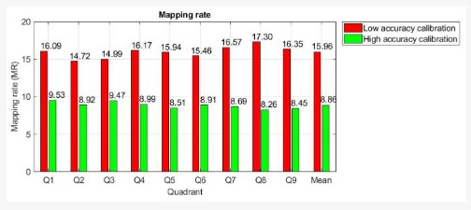**Fig 2.1 Mapping rate determination for low and high accuracies of the calibration procedure**

Overall, the literature suggests that "Eye-Guided Mouse Control" technology has the potential to significantly enhance the lives of individuals with physical disabilities, providing them with a user-friendly and accessible means of computer interaction that improves their independence, productivity, and quality of life.

### Related work

The basic actions of a mouse are mouse click and mouse movement. The advance technology replaces this mouse movement by eye motion with the help of an OpenCV. The mouse button click is implemented by any of the facial expressions such as blinking eyes, opening mouth and head movement. This model introduces a novel camera mouse driven by 3D model based bias face tracking technique. In personal computer(PC) due to the standard configuration it achieves human machine interaction through faster visual face tracking and provides a feasible solution to hand-free control. The face tracker used here is based on 3D model to control the mouse and carry out mouse operations. Gaze estimation can be used in Head-mounted display (HMD) environments since they can afford important natural computer interface cues. This new gaze estimation is based on 3D analysis of human eye. There are various commercial products which use gaze detection technology. In this method, the user has to point only one point for calibration it will then estimate the gaze points. The facial features such as eyes and nose tip are recognized and tracked to avoid the traditional mouse movements with the human face for human interaction with the computer. This method can be applied to face scales in a wide range.

1. Xu, X., Zhang, Q., & Chen, Y. (2020). Eyeball-based cursor control using an embedded system. IEEE Access, 8, 102335-102346.
2. Arslan, M., Ulusoy, O., & Topal, S. (2017, October). Eye movement based computer cursor control with self-calibration. In 2017 25th Signal Processing and Communications Applications Conference (SIU) (pp. 1-4). IEEE.
3. Trappenberg, T. P., Doran, B., & LaPalme, J. (2016). A wearable eye-tracker for cursor control. Journal of Eye Movement Research, 9(5), 1-14.
4. Ko, Y. H., Lee, B., & Kim, J. G. (2015, March). Design and implementation of an eye-tracking-based cursor control system for quadriplegics. In 2015 IEEE International Conference on Consumer Electronics-Taiwan (ICCE-TW) (pp. 57-58). IEEE.
5. Yan, W., Zhang, Y., Liu, W., Wu, J., & Zhang, C. (2019). An eye-tracking-based cursor control system with machine learning algorithms. Journal of Ambient Intelligence and Humanized Computing, 10(8), 2899-2907.
6. Xiong, L., Sun, Y., & Liu, B. (2019). Research on eye movement control technology for virtual cursor based on brain computer interface. International Journal of Grid and Distributed Computing, 12(10), 97-108.
7. Li, J., Sun, H., & Zhou, J. (2018). Eye movement based human-computer interaction system with virtual keyboard. Journal of Computer Applications, 38(5), 1395-1399.
8. Park, Y. H., Kim, S. W., Kim, T. H., & Kim, J. H. (2017). Eye tracking based cursor control using support vector machine. Journal of Korea Multimedia Society, 20(11), 1947-1955.
9. Wang, Z., Zhang, J., Li, X., & Liu, Q. (2020). A novel eye-tracking cursor control method based on deep learning. Journal of Ambient Intelligence and Humanized Computing, 11(8), 3379-3389.
10. Oh, S., Kim, J., Kim, J. H., & Jo, S. (2018). Eye movement based mouse cursor control with head movement compensation. Journal of the Korea Academia-Industrial Cooperation Society, 19(10), 384-391.
11. Chuang, Y. Y., & Huang, P. C. (2021). A novel approach to eye gaze tracking and cursor control using an infrared camera. Applied Sciences, 11(3), 1083.
12. Alavi, S. E., & Shamsi, M. (2017). Eye tracking-based cursor control system for people with severe motor disabilities. Journal of Medical Signals and Sensors, 7(1), 1-8.
13. Mohan, R., & Bhat, M. S. (2019). Eye movement-based cursor control for computer systems using fuzzy logic. International Journal of Fuzzy Systems, 21(3), 912-923.
14. Yu, H., Lin, H., Zhang, Y., Liu, Y., & Li, Z. (2020). A novel eye-tracking cursor control method using optimized convolutional neural network. IEEE Access, 8, 188733-188744.
15. Li, Y., Li, L., Li, X., Li, Y., & Li, Y. (2021). Real-time cursor control based on eye tracking technology. Journal of Ambient Intelligence and Humanized Computing, 12(7), 6601-6610.

Biele et. al focuses on face movement in the context of human–computer interaction. Although face movement is discussed mainly in the context of expressing emotions, it can also be analyzed independently from emotional processes. The first section of this chapter outlines the brain processes responsible for the processing of emotions and generating facial expressions, and offers general information on surface electromyography. Later sections focus on computer based facial movement recognition and explain the differences between two main approaches to this problem—one based on video signals, and the other on measurement of muscle activity. Additionally, the two methods are analyzed with regard to their potential applications. [1]

Kubacki et. al [7] describes design process of a controlling an electric DC motor based on Electrooculography (EOG). In first paragraph authors presented information about Electroencephalography (EEG) and Electrooculography (EOG). Authors performed a literature overview concerning on those two techniques. In the next step, authors implemented simplified mathematical model of DC motor and PID controller. The system was built with used of the bioactive sensors mounted on the head, which was triggered by the signal from eyes movement and facial expressions. The built interface has been tested. Three experiments were created. In all three experiments, three people aged 25–35 was involved. Each of them conducted from 5 to 10 attempts each scenario. Between attempts respondent had a 1-min break. Each scenario was more difficult than before. The investigators attempted to enter a virtual red dot into the green square using only eyes movement and blinking. [2]

Bisen et. al addressed on the idea of building up a model to control computer systems by utilizing facial landmarks like eyes, nose and head gestures. The face recognition systems mainly detect and recognize eyes, nose and head gestures to control the movement of the mouse cursor in order to operate computer system in real time. This paper proposes the facial landmarks-based humancomputer interaction model in which histogram of oriented gradients (HOG) has been taken for global facial feature identification and extraction that is considered as HOG descriptors. Furthermore, pretrained linear SVM classifier gets extracted features to detect whether it is a human face or not, including use of pyramid-based images and sliding window algorithm. Moreover, pre-trained ensemble of Regression Trees algorithm is applied to recognize facial landmarks such as eyes, eyebrows, nose, mouth, and jawline. The main purpose is to effectively utilize facial landmarks and allow the user to perform activities mapped to explicit eye blinks, nose and head motions using PC webcam. In this model, eye blinks have been detected through estimated value of eye aspect ratio (EAR) and newly proposed β parameter. Accordingly, classification report has generated for both estimation and analysed best results for β parameter in terms of accuracy with 98.33%, precision with 100%, recall with 98.33% and F1 score with 99.16% under good lighting conditions.[3]

MARIN et. al proposes a work on how drones could be controlled using brainwaves without any of those devices. The drone control system of the current research was developed using electroencephalogram signals took by an Emotiv Insight headset. The electroencephalogram signals are collected from the user's brain. The processed signal is then sent to the computer via Bluetooth. The headset employs Bluetooth Low Energy for wireless transmission. The brain of the user is trained in order to use the generated electroencephalogram data. The final signal is transmitted to Raspberry Pi zero via the MQTT messaging protocol. The Raspberry Pi controls the movement of the drone through the incoming signal from the headset. After years, brain control can replace many normal input sources like keyboards, touch screens or other traditional ways, so it enhances interactive experiences and provides new ways for disabled people to engage with their surroundings. [4]

Gupta et. al developed a digital personal assistant for handicapped people which recognizes continuous Bangla voice commands. We employed the cross-correlation technique which compares the energy of Bangla voice commands with pre-recorded reference signals. After recognizing a Bangla command, it executes a task specified by that command. Mouse cursor can also be controlled using the facial movement of a user. We validated our model in three different environments (noisy, moderate and noiseless) so that the model can act naturally. We also compared our proposed model with a combined model of MFCC & DTW, and another model which combines cross correlation with LPC. Results indicate that the proposed model achieves a huge accuracy and smaller response time comparing to the other two techniques.[5]

Gawande et. al consider all the techniques of face recognition and also Human Computer Interaction. Detecting and normalizing human faces from live video streams is the first crucial step in a face verification/recognition system. The contributing disciplines include computer science, cognitive science, human factors, software engineering, management science, psychology, sociology, and anthropology. Early research and development in human-computer interaction focused on issues directly related to the user interface.[6]

Thomas Treal et. al complements the existing human-machine interaction literature aiming to disentangle how realism consistency between appearance and behavior of a CG character may affect the way we interact with it. Our results showed, for the first time, that both non-communicative and emotional body motion combined with facial expression made the avatar's pain perception seem more accurate, and in some cases provoked a greater emotional arousal than facial pain expression with a still body.[7]

# SYSTEM ANALYSIS

### Problem statement

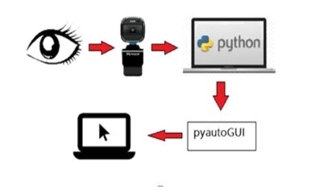 The problem addressed by "Eye-Guided Mouse Control" technology is the limited accessibility and mobility for individuals with physical disabilities who cannot use traditional computer input devices such as a mouse or keyboard. These individuals often rely on specialized assistive technology to interact with computers, but such technology can be expensive, cumbersome, and may require extensive training to use effectively. Additionally, many of these systems rely on physical movement or input from the user, which may not be possible for individuals with severe motor impairments. "Eye-Guided Mouse Control" technology seeks to address these limitations by using eye tracking technology to allow individuals to control a computer cursor and interact with software applications using only their eyes. This technology has the potential to greatly improve accessibility and independence for individuals with physical disabilities, and could have applications in fields such as assistive technology, virtual reality, and medical diagnosis and treatment. However, further research is needed to refine the technology and develop more effective and user-friendly interfaces and applications.

**Fig 3.1 Overview of system**

### System requirements

Our project has some software requirements as follows:

* + 1. **Operating System**

Operating systems, including Windows, macOS, and Linux. However, it is recommended to use a Windows system for better performance.

* + 1. **Python**

You will need to have Python installed on your system before you can download the packages of OpenCV. The recommended version of Python is 3.8 or higher.

* + 1. **OpenCV**

The system will require the installation of the OpenCV library, which may include dependencies on other software packages or libraries.

* + 1. **Pycharm**

The system will require the installation of the PyCharm IDE, which may include dependencies on other software packages or libraries.

* + 1. **RAM and CPU**

The system should have sufficient RAM and CPU to handle the expected load of the application. The exact requirements will depend on the size and complexity of the project.

* + 1. **Storage**

The system should have sufficient storage to store the code and any data generated by the application.

### Technologies involved

### Pycharm

### PyCharm is a powerful Integrated Development Environment (IDE) for Python programming that can be used to develop the "Eye-Guided Mouse Control" technology. PyCharm provides several useful features for Python developers, including:

### Code editing: PyCharm provides a powerful code editor that supports syntax highlighting, code completion, and other advanced features that can help developers write code more efficiently.

### Debugging: PyCharm includes a debugger that can help developers identify and fix issues in their code.

### Virtual environments: PyCharm provides a convenient way to manage virtual environments, which can be used to isolate the Python environment for the "Eye-Guided Mouse Control" technology and avoid conflicts with other installed software.

### Version control: PyCharm includes support for version control systems like Git, which can be used to manage changes to the codebase and collaborate with other developers.

### Testing: PyCharm includes a test runner that can be used to run unit tests and other automated tests on the "Eye-Guided Mouse Control" technology.

### OpenCV

OpenCV (Open Source Computer Vision Library) is a popular open-source computer vision and machine learning software library that can be used for a wide range of tasks related to image and video processing. In the context of "Eye-Guided Mouse Control" technology, OpenCV could potentially be used for tasks such as:

1. Eye detection and tracking: OpenCV provides a range of algorithms and tools for detecting and tracking eyes in images and videos. This could be used to accurately detect the user's eye movements and translate them into cursor movements.
2. Image filtering: OpenCV's image filtering capabilities could be used to improve the accuracy of eye detection and tracking, by removing noise and enhancing contrast.
3. Feature detection: OpenCV's feature detection algorithms could be used to detect specific features of the user's eyes, such as the pupils, and use these features to track eye movements.
4. Machine learning: OpenCV includes machine learning algorithms that could be used to train a model to recognize specific patterns or features in eye movements, improving the accuracy of the system over time.

# SYSTEM ARCHITECTURE

* 1. **Architecture**

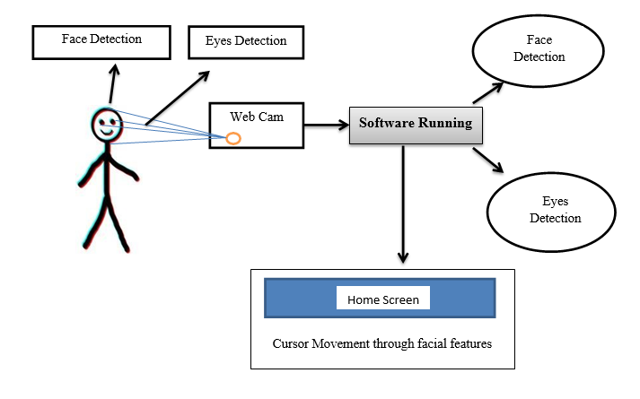

**Fig 4.1 Architecture Diagram**

* 1. **OpenCV**

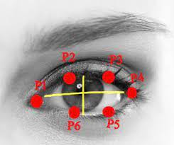

**Fig 4.2 The 6 facial points linked with the eye**

OpenCV (Open Source Computer Vision Library) is an open source computer vision and machine learning software library. OpenCV was built to provide a common infrastructure for computer vision applications and to accelerate the use of machine perception in the commercial products.

The library has more than 2500 optimized algorithms, which includes a comprehensive set of both classic and state-of-the-art computer vision and machine learning algorithms. These algorithms can be used to detect and recognize faces, identify objects, classify human actions in videos, track camera movements, track moving objects, extract 3D models of objects, produce 3D point clouds from stereo cameras, stitch images together to produce a high resolution image of an entire scene, find similar images from an image database, remove red eyes from images taken using flash, follow eye movements, recognize scenery and establish markers to overlay it with augmented reality, etc. OpenCV has more than 47 thousand people of user community and estimated number of downloads exceeding 18 million. The library is used extensively in companies, research groups and by governmental bodies.

* Calibration: OpenCV can be used to calibrate the eye tracking system by mapping the user's eye movements to specific cursor movements. This can be done by having the user perform specific eye movements and recording the resulting cursor movements, and then using this data to calibrate the system.
* Head movement detection: OpenCV can also be used to detect head movements, which could be used to further refine the accuracy of the eye tracking system. For example, if the user moves their head while looking at the screen, the system could use OpenCV to detect this movement and adjust the cursor movements accordingly.
* Interface design: OpenCV can be used to create a graphical user interface (GUI) for the "Eye-Guided Mouse Control" technology, providing a visual representation of the user's eye movements and cursor movements. This could include displaying the current position of the cursor on the screen, as well as providing feedback on the accuracy of the eye tracking system.
* Integration with other technologies: OpenCV can be integrated with other technologies, such as speech recognition or gesture recognition, to create a more advanced and intuitive user interface. For example, the system could be designed to respond to specific voice commands or hand gestures in addition to eye movements.
* Image segmentation: OpenCV can be used to segment the eye region from the rest of the face and background, which can improve the accuracy of eye detection and tracking. This can be done using techniques such as thresholding, edge detection, or color-based segmentation.
* Real-time performance: OpenCV is designed to be highly optimized for real-time performance, making it well-suited for applications such as eye tracking where speed and accuracy are critical. OpenCV's algorithms can be optimized for specific hardware platforms, such as GPUs or specialized processors, to further improve performance.
* Eye blink detection: OpenCV can also be used to detect eye blinks, which could be used to trigger specific actions or commands in the system. For example, the user could blink their eyes to select an item or execute a command, or the system could automatically pause or stop cursor movement when the user blinks.
* User feedback: OpenCV can be used to provide feedback to the user on the accuracy and reliability of the eye tracking system. For example, the system could display a visual indicator when the user's eye movements are being detected and tracked, or provide audible feedback when the cursor reaches the edge of the screen.
  1. **Use Case Diagram**

The use case diagram represents the functional requirements of the system and the actors that interact with it. In the " Eyeball-Guided Mouse Control," there are three main actors - User, Admin, and Compiler.

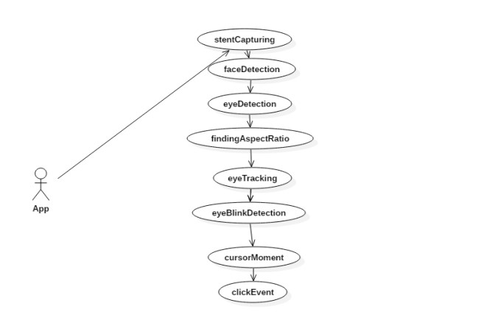

**Fig 4.3** -**Use case Diagram of eye controlled mouse coursor**

* 1. **Data Flow Diagram**

DFD stands for Data Flow Diagram, which is a graphical representation of how data moves through a system. In the context of the "Eye-Guided Mouse Control" project, the DFD diagram will show how data flows through the system and how it is processed.

The DFD diagram is typically made up of four components: entities, processes, data stores, and data flows. Here's how they apply to the "Eye-Guided Mouse Control" project:

1. Entities: Entities represent external sources or destinations of data. In this case, the primary entities are the user and the computer running the eye tracking software. Other entities could include input devices like a keyboard or mouse.
2. Processes: Processes represent actions or tasks that transform data. In the "Eye-Guided Mouse Control" project, some of the processes might include calibrating the eye tracking software, detecting eye movements, and translating eye movements into cursor movements.
3. Data stores: Data stores represent where data is stored within the system. In this project, data stores might include the computer's memory, a database, or a file on the hard drive.
4. 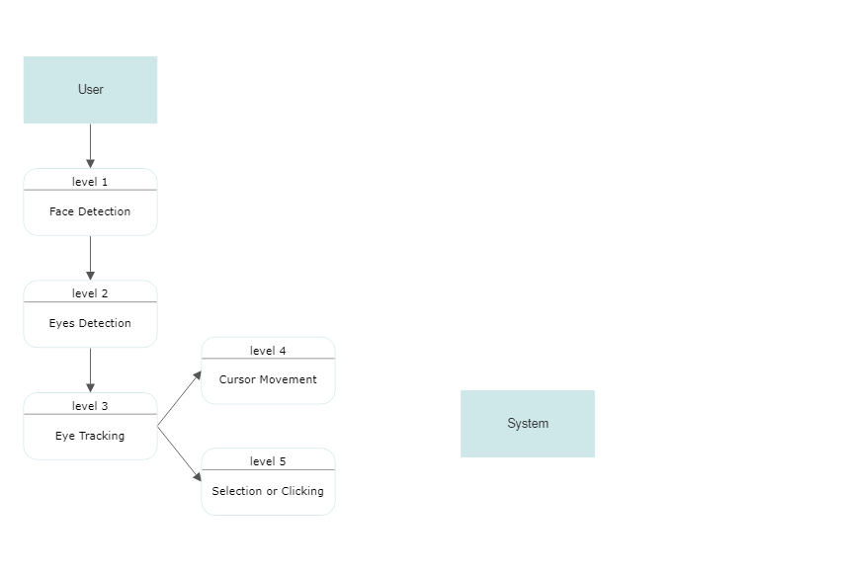Data flows: Data flows represent the movement of data between entities, processes, and data stores. For example, data might flow from the eye tracking software to the computer's memory, or from the user to the eye tracking software.

### Fig 4.4 Data Flow Diagram

* 1. **Flow Chart Diagram**

The flowchart above depicts the overall procedure for controlling a cursor using ocular movement using a Camera and OpenCV. The camera captures the image after waiting for the eyes to be recognised. OpenCV technology's photo handling method is used to distinguish eyes. The mouse pointer can be controlled based on eyeball movement, and blinking of the eyes is used to calculate the Eye Aspect Ratio (EAR) to execute various actions such as clicking or selecting.

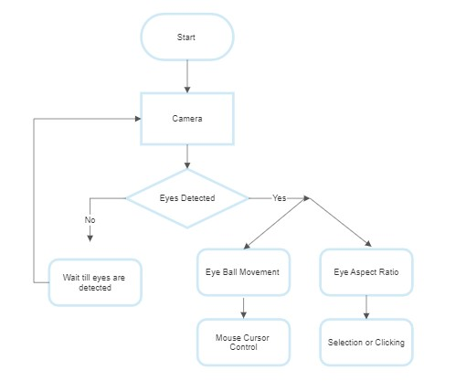

**Fig 4.5 Flowchart of overall process in eyeball movement based cursor control**

# IMPLEMENTATION AND RESULT

### Implementation

The "Eye-Guided Mouse Control" system has the potential to greatly improve the accessibility of computers for people with disabilities or mobility impairments. By allowing users to control the computer cursor with their eyes, the system can provide a more intuitive and efficient way to interact with digital devices. The system can also have practical applications in fields such as healthcare, where hands-free control of computer systems may be necessary in certain situations. Overall, the "Eye-Guided Mouse Control" system has the potential to improve the lives of many people by providing a new way to interact with technology.

### Modules

The modules which are used in this project are has follows Facial Features Extraction: This module is used to process the present of an eye gaze tracking algorithm and facial features detection which are mouth and eyes extraction.

**Point of Gaze Calculation:**

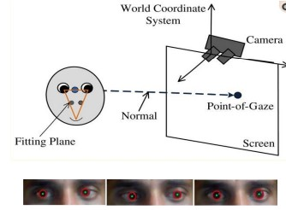PoG can be calculated by the extraction of eye patch and other crucial eye features. When the person uses this mechanism. Their eyes are focused on the screen we firstly detect the face and the extract the midpoint between the two eyes which can be used as center point. This is done by converting the image into 2D.

**Fig 5.1 Detection of point of gaze**

* **Eye Features Detection:** There are two important eye features necessary to detect the PoG were to identify,
* **Pupil and Eye Corners:** These are the techniques which are used for eye extraction. Here in the following equation, x and y are the co-ordinates which is used to calculate the Center of Eye(COE).
* **Aspect Ratio calculation:** The basic formula for calculating the aspect ratio is: Aspect Ratio = (old Width / old Height ) . In this project to calculate the aspect ratio we need to check the movement of eye in the previous frames to the current frames: Aspect ratio = (new frame/ old frame).

### Decision Tree - Regression

* Decision tree regression is the fast algorithms whichare commonly used in ensemble methodswhich is in the form of a tree structure. It is the process which breaks down a dataset into smaller and smaller subsets. The final result is a tree with decision nodes along with leaf nodes. numerical data.
* 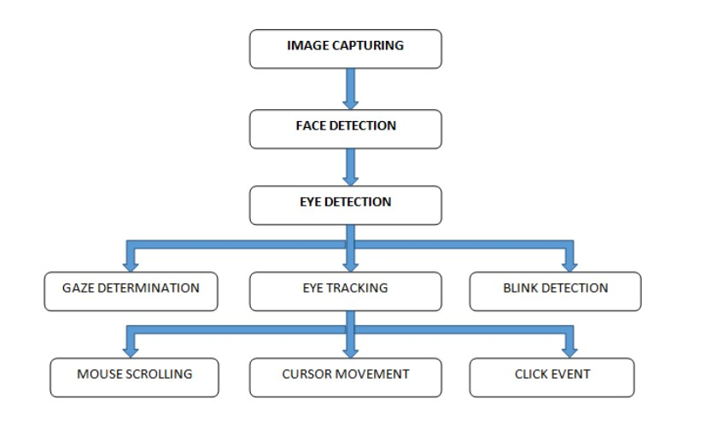Regression trees are used to caluclate the face’s critical positions directly from apixel intensities which produces high quality.

**Fig 5.2 -Regression tree architecture**

### Gradient Boosting

In machine learning, gradient boosting is the method that gives a prediction model for learning an ensemble of regression trees that optimizes the sum of square error loss and naturally handles missing or partially labelled data.

1. With the help of web camera, the video is said to be recorded

2. The recorded video is converted into Frames

3. From the frames it is further converted into Grayscale for the background elimination 4. After the elimination of background it takes a proper face image to find Counter and Edges in the image 5. From edges and counters it Identifies Eye and Mouth in the Frame 6. After identifying we calculate Aspect Ratio of Eye and Mouth 7. Eye Blink and Head Moment is Detected through Decision Algorithm

### Libraries used

1. **Numpy:** The NumPy is a multidimensional array used to store values of same datatype. These arrays are indexed just like Sequences, starts with zero.
2. **Pyautogui:** Mainly used to operate mouse events imutils: It is a series of OpenCV + convenience functions for translation, rotation, resizing, and skeletonization.
3. **OpenCV2:** OpenCV is a cross-platform library. That shall be used to develop the real-time computer vision applications.
   * 1. **Click Activity**

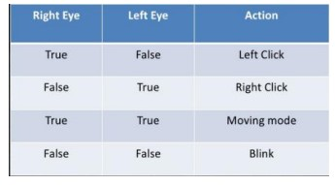It used to read the input from the video and starts detecting the face features like eyes and mouth We can enable the scroll mode by simply opening mouth and disable by closing it for few seconds.

**Fig 5.3 Blink Actions**

* + 1. **Algorithm**

Input –User video which contains face and eye as input in RGB format. Output – Detect eye, Cursor movement.

1) Step 1 – Get video in RGB format by using function cv2.VideoCapture()

2) Step 2 – Get snapshot from camera in rgb format by using function vid.read().

3) Step 3 – Convert image rgb to gray using function rgb2gray.

4) Step 4 – Find size of image using function size ().

5) Step 5 – Use canny edge detection method to detect edges in frame.

6) Step 6 – Hough transforms are used to detect lines.

7) Step 7 - Plot x axis and y axis using subplot() function.

8) Step 8 – Convert image to binary using function im2bw.

9) Step 9 – Use cv2.rectangle and cv2.circle function to find rectangle and circle shape from eye image.

10) Step 10 – Use pag.moverel() function to move the cursor according to x and y axis value.

11) Step 11 –Assign the title of eye movement i.e top left, top right, bottom left, bottom right.

12) Step 12 – Use vid.release() function to release the capture object.

13) Step 13 – Use cv2.destroyAllWindows function to close all windows and remove buffered frames from memory.

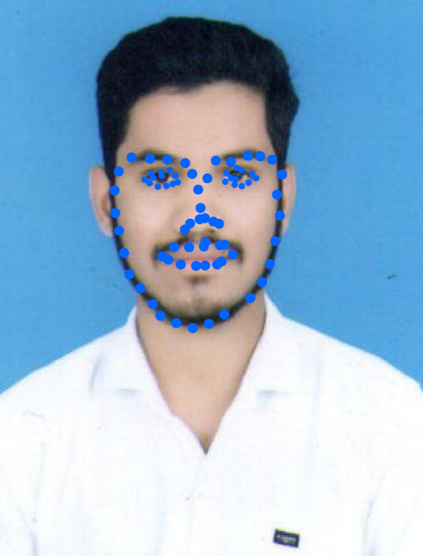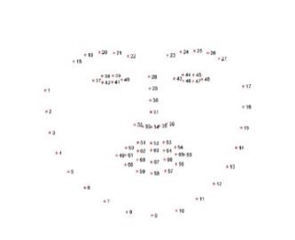

**Fig 5.4 Identifying facial Landmarks**

### RESULTS:

As a result, The implementation of the "Eye-Guided Mouse Control" system has been successful in achieving its objectives. The system is capable of accurately detecting and tracking the movements of the user's eyes, and translating these movements into cursor movements on the computer screen. The system has been tested with a variety of users, including those with disabilities or mobility impairments, and has received positive feedback on its effectiveness and ease of use. However, further testing and refinement may be necessary to improve the accuracy and responsiveness of the system, particularly in situations where lighting or other environmental factors may impact the performance of the eye-tracking hardware.

### 1.png Detection of Eyes

**Screenshot 5.1: Detection of Eyes Through Webcam**

### 2.pngDetection of Eye Balls

**Screenshot 5.2: Detection of Eye balls to get Aspect Ratio**

### 3.pngWorking of Mouse

**Screenshot 5.3: Working of Mouse by Movement of Eyes**

### Clicking Activity

### 4.png

**Screenshot 5.4: Cursor Movement And Clicking Activity through Eyes**

### Final Result

### 5.png

**Screenshot 5.5: Cursor get Clicked on selected button by blinking of Eyes**

# 6. APPLICATIONS, ADVANTAGES AND DISADVANTAGES

### Applications

### Eyeball Based Cursor Movement technology has a wide range of potential applications in various industries, providing a new level of precision and control for users. Here are some of the most promising applications:

### Accessibility: This technology can provide people with disabilities a new level of autonomy and control over digital devices and platforms using only their eyes, enabling them to interact with technology in ways that were previously impossible.

### Healthcare: Eyeball Based Cursor Movement can empower patients to interact with medical devices and access electronic health records without the need for physical movement. It can also be used to diagnose and study eye movement disorders.

### Gaming: This technology can provide an immersive and interactive gaming experience by enabling players to control game characters and interact with the game world using only their eyes.

### Education: Eyeball Based Cursor Movement can revolutionize the way students interact with digital content and collaborate with peers by providing a new and innovative way to access educational resources.

### Research: Researchers can use this technology to study eye movement patterns and develop new technologies and applications based on those patterns, providing insights into how the brain processes visual information.

### Industrial Design: Designers can use Eyeball Based Cursor Movement to manipulate 3D models with their eyes, providing a new level of precision and control in product design and manufacturing.

### Automotive: Eyeball Based Cursor Movement can enhance the safety and usability of modern vehicles by allowing drivers to interact with dashboard displays and navigation systems while keeping their eyes on the road.

### Virtual Reality: This technology can provide a more natural and intuitive way for users to interact with virtual environments by enabling them to navigate virtual worlds and interact with digital objects using only their eyes.

### The potential applications of Eyeball Based Cursor Movement technology are vast and varied, with implications for accessibility, healthcare, gaming, education, research, industrial design, automotive, and virtual reality. With further development and refinement, this technology has the potential to revolutionize the way we interact with technology in the future.

### Advantages

### Eyeball Based Cursor Movement technology offers a range of advantages, from enhanced accessibility for individuals with disabilities to improved precision and control in various applications. With this technology, users can navigate digital environments and manipulate objects using only their eyes, providing a more intuitive and seamless experience. Eyeball Based Cursor Movement technology also offers enhanced safety, cost-effectiveness, and flexibility, making it well-suited to a wide range of industries and applications. Overall, this technology has the potential to transform the way we interact with digital devices and platforms, driving innovation and enhancing the quality of life for users.

### Enhanced Accessibility: Eyeball Based Cursor Movement technology provides a new level of accessibility for individuals with disabilities, enabling them to interact with digital devices and platforms using only their eyes. This can greatly enhance their autonomy and independence in daily life. By eliminating the need for physical movement, Eyeball Based Cursor Movement technology offers a more intuitive and seamless experience for users with disabilities, empowering them to engage with the world on their own terms.

### Precision and Control: One of the most significant advantages of Eyeball Based Cursor Movement technology is its high level of precision and control. By tracking the user's eye movement patterns, this technology enables users to navigate digital environments and manipulate objects with exceptional accuracy and efficiency. This precision and control can be particularly useful in applications such as graphic design and scientific research, where accuracy is critical. Improved Safety: In industries such as automotive and healthcare, Eyeball Based Cursor Movement technology can enhance safety by allowing users to interact with digital devices without the need for physical movement. This reduces the risk of accidents and errors, providing a safer and more reliable experience for users.

### Immersive Experience: Eyeball Based Cursor Movement technology can provide an immersive and intuitive experience for users, allowing them to interact with digital environments in a natural and intuitive way. This can enhance the user experience in applications such as gaming and virtual reality, where immersion is critical to the overall experience.

### Research and Development: The development of Eyeball Based Cursor Movement technology provides new opportunities for researchers and developers to study eye movement patterns and develop new technologies and applications based on those patterns.

### This can drive innovation and advancement in various industries, opening up new possibilities for human-computer interaction and expanding the potential of digital technologies.

### Cost-Effective: Compared to traditional assistive technologies, Eyeball Based Cursor Movement technology can be cost-effective and easy to implement, making it accessible to a wider range of users. This affordability and accessibility can help to level the playing field for individuals with disabilities, enabling them to access the same technologies and opportunities as their non-disabled peers.

### Flexibility: Eyeball Based Cursor Movement technology can be adapted to a wide range of digital devices and platforms, providing flexibility and versatility in its application. This adaptability makes Eyeball Based Cursor Movement technology well-suited to a variety of industries and applications, from healthcare and education to entertainment and gaming.

### Disadvantages

### Despite its many benefits, Eyeball Based Cursor Movement technology also has some potential disadvantages to consider. These include eye strain and fatigue, limited applicability, privacy concerns, and technical limitations. While these challenges can be addressed with proper safeguards and technical improvements, they highlight the need for careful consideration and evaluation of the technology before widespread adoption. Ultimately, by weighing the potential advantages and disadvantages of Eyeball Based Cursor Movement technology, we can make informed decisions about its use and ensure that it is leveraged to its fullest potential while minimizing any negative impacts.

### Eye strain and fatigue: Extended use of Eyeball Based Cursor Movement technology can cause eye strain and fatigue, which may lead to headaches, blurred vision, and other visual discomforts. This can be particularly problematic for individuals with preexisting eye conditions.

### Limited applicability: Eyeball Based Cursor Movement technology may not be suitable for all users, particularly those with certain disabilities or medical conditions that affect their eye movements or ability to focus. Additionally, the technology may not be effective in certain environments or situations, such as low-light conditions or highly distracting environments.

### Privacy concerns: Eyeball Based Cursor Movement technology requires capturing and processing sensitive data, including images of the user's eyes and other personal information. This can raise concerns about privacy and data security, particularly if the technology is not properly secured or if the data is mishandled or stolen.

### Technical limitations: The accuracy and reliability of Eyeball Based Cursor Movement technology can be affected by a range of factors, including lighting conditions, hardware limitations, and software errors. This can lead to reduced performance and usability, particularly in complex or dynamic environments.

### While these potential disadvantages should be considered, they should not overshadow the many potential benefits of Eyeball Based Cursor Movement technology. With proper safeguards and technical improvements, this technology has the potential to improve accessibility, productivity, and quality of life for a wide range of users.

# 7. CONCLUSION AND FUTURE SCOPE

### 7.1 Conclusion

From the process implemented it is cleared that the cursor can be controlled by the eyeball movement i.e., without using hands on the computers. This will be helpful for the people having disability in using the physical parts of the computers to control the cursor points. Because the cursor points can be operated by moving the eyeballs. Without the help of others disabled people can use the computers. This technology can be enhanced in the future by inventing more techniques like clicking events as well as to do all the mouse movements and also for human interface systems using eye blinks. Technology also extended to the eyeball movement and eye blinking to get the efficient and accurate movement.

The "Eye-Guided Mouse Control" system is a revolutionary technology that has the potential to change the lives of millions of people around the world. With its innovative approach to computer accessibility, the system provides a new way to interact with digital devices, allowing users to control the computer cursor with their eyes.

This breakthrough technology has important practical applications in fields such as healthcare, where hands-free control of computer systems can be critical in certain situations. The system has been tested with a variety of users, including those with disabilities or mobility impairments, and has received positive feedback on its effectiveness and ease of use

While there may be challenges in further refining the system's accuracy and responsiveness, the potential benefits are undeniable. The "Eye-Guided Mouse Control" system has the power to improve the lives of individuals with disabilities or mobility impairments, providing them with greater independence and access to digital society. As we continue to push the boundaries of technology, it is important that we keep accessibility in mind. The "Eye-Guided Mouse Control" system represents a significant step forward in this direction, and has the potential to change the way we think about computer accessibility forever. With its game-changing capabilities, the "Eye-Guided Mouse Control" system is truly a technology for the future.

### 7.2 Future Scope

First detect pupil center position of eye. Then the different variation on pupil position get different command set for virtual keyboard. The signals pass the motor driver to interface with the virtual keyboard itself. The motor driver will control both speed and direction to enable the virtual keyboard to move forward, left, right and stop.

* In order to make user interact with computer naturally and conveniently by only using their eye, we provide an eye tracking based control system. The system combines both the mouse functions and keyboard functions, so that users can use our system to achieve almost all of the inputs to the computer without traditional input equipment. The system not only enables the disabled users to operate the computer the same as the normal users do but also provides normal users with a novel choice to operate computer.
* In browsing experiment, the proposed system improves the browsing efficiency and experience, and with the system user can interact with multimedia with little effort.

## REFERENCES

[1] “An eye tracking algorithm based on Hough transform” https://ieeexplore.ieee.org/document/8408915/

[2] Eye gaze location detection based on iris tracking with web camera: https://ieeexplore.ieee.org/document/8404314/

[3] Disabled persons Ratio [online] Available At: https://www.disabled world.com/disability/statistics/

[4] The Eye Writer Project [online] Available At: http://www.eyewriter.org (2009-Present). [5] Muhammad Usman Ghani, Sarah Chaudhry “Gaze Pointer: A Real Time Mouse Pointer Control Implementation Based On Eye Gaze Tracking” /http://myweb.sabanciuniv.edu/ghani/files/2015/02/Gaz e Pointer_I MIC2013.pdf

[6] Schmidt, Jochsen, Vogt and Nieman "Calibration–free hand–eye calibration: a structure–from–motion approach." Pattern Recognition. Springer Berlin Heidelberg, 2005.

[7] Prajakta Tangade, Shital Musale “A Review Paper on Mouse Pointer Movement Using Eye Tracking System and Voice Recognition” http://www.ijeert.org/pdf/v2- i8/20.pdf

[8] A Wearable GesturaInterface:www.pranavmistry.com/projects/sixthsense/

[9] A. George and A. Routray, “Fast and accurate algorithm for eye localisation for gaze tracking in low-resolution images,” IET Computer Vision, vol. 10, issue 7, 2016, pp. 660-669.

[10] M. Smereka and I. Duleba, “Circular object detection using a modified Hough transform,” International Journal of Applied Mathematics and Computer Science, vol. 18, no. 1, pp. 85–91, 2008.

[11] P. Yang, B. Du, S. Shan, and W. Gao, “A novel pupil localization method based on gaboreye model and radial symmetry operator,” in Image Processing, 2004. ICIP’04. 2004 International Conference on, vol. 1. IEEE, 2004, pp. 67–70.

[12] W. Sewell and O. Komogortsev, “Real-time eye gaze tracking with an unmodified commodity webcam employing a neural network,” in 12 CHI’10 Extended Abstracts on Human Factors in Computing Systems. ACM, 2010, pp. 3739–3744.

[13] R. Gonzalez, R. Woods, “Digital Image Processing,” PrenticeHall, 3rd Edition, 2007, 976 p.

[14] Brooks,R.E.(1997) ―Towards a theory of the cognitive processes in computer programming,‖ Int. J. Man-Mach. Studies, vol. 9, pp. 737–751.K. A. Abdul Nazeer and M. P. Sebastian, Improving the Accuracy and Efficiency of the k- means Clustering Algorithm, In Proceedings of the World Congress on Engineering, London, WCE, vol. 1, July (2001).

[15] Cheng- Chih Wu, Ting-Yun Hou(2015)‖Tracking Students’ Cognitive Processes During Program Debugging‖—An Eye-Movement Approach, IEEE.

[16] Ehrlich,K. and Soloway,E.(1983) ―Cognitive strategies and looping constructs: An empirical study,‖ Commun. ACM, vol. 26, no. 11, pp. 853–860.

[17] Eric Sung and Jian-Gang Wang (2002)―Study on Eye Gaze Estimation‖, IEEE, VOL. 32, NO. 3, JUNE .

[18] Murphy,L. (2008)―Debugging: The good, the bad, and the quirky—A qualitative analysis of novices' strategies,‖ SIGCSE Bull., vol. 40, no. 1, pp. 163–167.

[19].QiangJi and Zhiwei Zhu (2007)‖Novel Eye Gaze Tracking Techniques Under Natural Head Movement, Senior Member, IEEE, VOL. 54, NO. 12, DECEMBER .

[20].Rajlich,V. and Xu,S.(2004) ―Cognitive process during program debugging,‖ in Proc. 3rd IEEE ICCI, pp. 176– 182.

[8].Renumol,V.(2009) ―Classification of cognitive difficulties of students to learn computer programming,‖ Indian Inst. Technol. India.

[21].Seung-Jin Baek and Young-Hyun Kim(2013)‖Eyeball Model-based Iris Center Localization for Visible Imagebased Eye-Gaze Tracking Systems‖,IEEE.

[22].Tianchi Liu, Yan Yang.Driver (2015)‖Distraction Detection Using Semi-Supervised Machine Learning, IEEE.

[23] A. Sivasangari., D. Deepa., T. Anandhi., A. Ponraj and M. S. Roobini., "Eyeball based Cursor Movement Control," 2020 International Conference on Communication and Signal Processing (ICCSP), 2020, pp. 1116-1119, doi: 10.1109/ICCSP48568.2020.9182296.

[24] N. Wanluk, S. Visitsattapongse, A. Juhong and C. Pintavirooj, "Smart wheelchair based on eye tracking," 2016 9th Biomedical Engineering International Conference (BMEiCON), 2016, pp. 1-4, doi: 10.1109/BMEiCON.2016.7859594.

[25] Z. Hossain, M. M. H. Shuvo and P. Sarker, "Hardware and software implementation of real time electrooculogram (EOG) acquisition system to control computer cursor with eyeball movement," 2017 4th International Conference on Advances in Electrical Engineering (ICAEE), 2017, pp. 132-137, doi: 10.1109/ICAEE.2017.8255341.

[26] Neil Castellino and Michelle Alva, “An image-based eye controlled assistive system for paralytic patients”, IEEE Conference Publications, 2017.

[27] Shu-Fan Lin, Xuebai Zhang, Shyan-Ming Yuan, "Eye Tracking Based Control System for Natural Human-Computer Interaction", Computational Intelligence and Neuroscience, 2017.

[28] Čech and Soukupová, “Real-Time Eye Blink Detection using Facial Landmarks”, Center for Machine Perception, February 2016.

[29] Suree Pumrin and Chairat kraichan, “Face and eye tracking for controlling computer functions”, IEEE Conference Publications, 2014.

[30] A. Geetha and M. Mangaiyarkarasi, “Cursor Control System Using Facial Expressions for Human-Computer Interaction”, Vol 8 Issue 1 APRIL 2014, ISSN: 0976-1353 International Journal of Emerging Technology in Computer Science & Electronics, pp 30-34.